State Diagram

Name: Vyom Pathak

ID: 17CEUON038

Roll No. : CE099

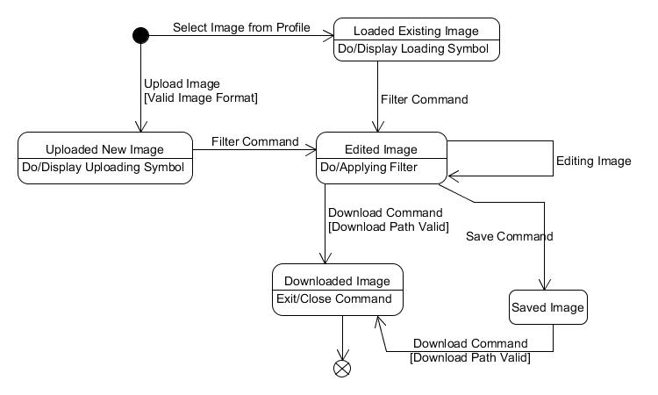

Image State Diagram